Resume Chat feature like ChatGPT
This is what we will do. The idea is to create a side bar where we can resume our old converstation.
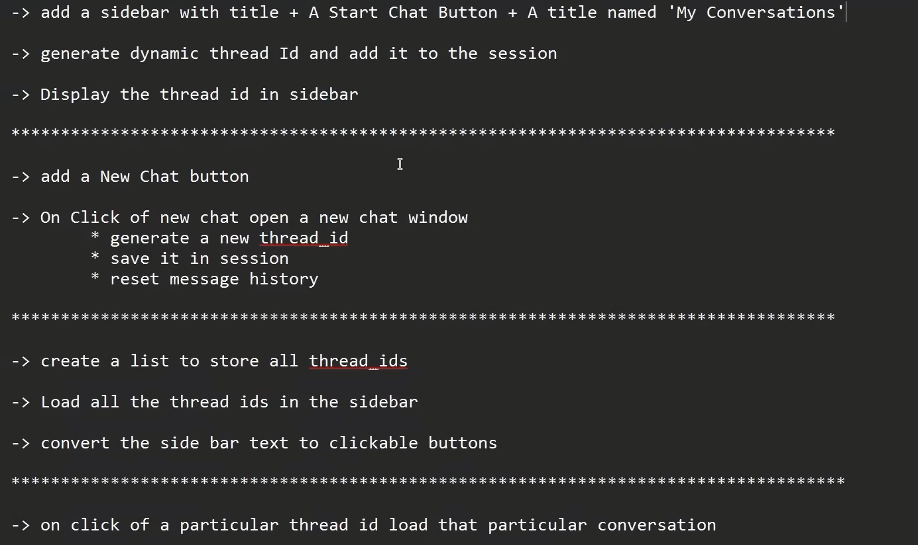
Result:-
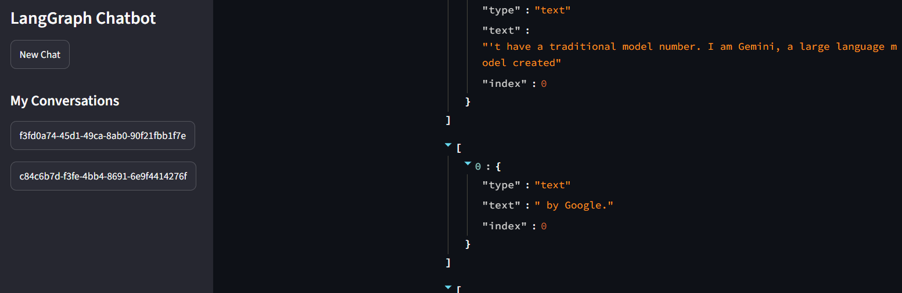
Code:- We have to create a new thread_id for each new conversation each time we create a new chat. This is where uuid comes into picture. It does exactly that
generate_thread_id - This function generates a unique ID for each chat session using uuid.uuid4().
Intuition: Every new chat gets its own unique conversation ID, which can be used by LangGraph to maintain separate conversation histories.
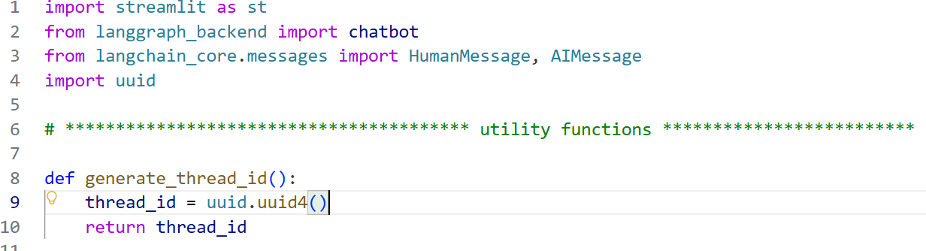
reset_chat function - This function generates a new thread_id using the generate_thread_id() function and stores it in st.session_state['thread_id'].
We then use add_thread() to store the new thread ID so that the previous chat thread can be preserved and accessed later. Finally, we clear message_history so the new chat starts with an empty conversation.
Intuition: Create a new chat ID → preserve the old thread → clear the visible history → start a fresh chat.

add_thread function – This function adds the thread_id to st.session_state['chat_threads'] if that thread ID is not already present.
It is called when reset_chat() runs, which happens when we click "New Chat". This allows us to store the ID of the chat we were just using so that its conversation can be accessed later.
Intuition: When you click New Chat, we save the current chat's ID in the list of chat threads before starting the new conversation.

Load_conversation function – We use chatbot.get_state() with the thread_id to retrieve the saved state of that particular conversation. From that state, we access the messages to load the entire previous chat history.
return state.values.get('messages', []) – Here state.values contains the saved state of that conversation. And get('messages', []) → looks for the messages key. If it exist then give me the list of messages otherwise return an empty list instead of an error.
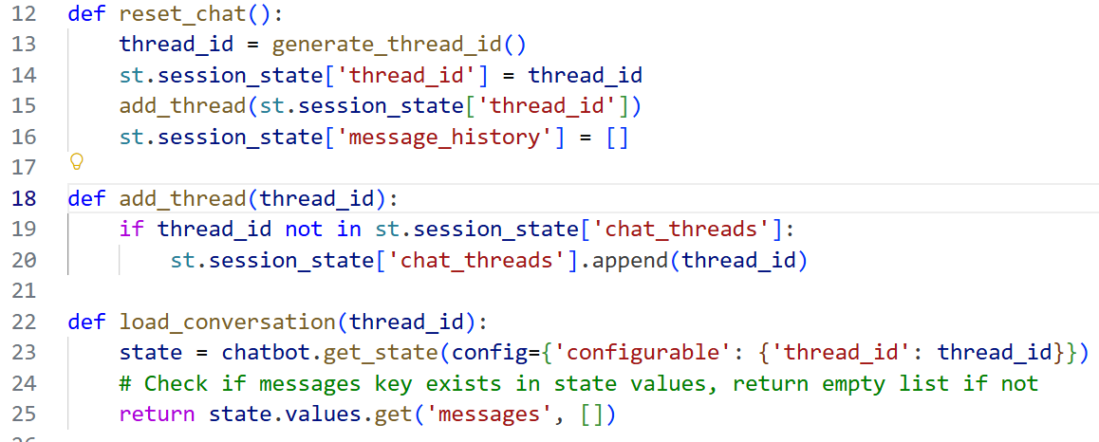
Code:- We can do something like this to extract message associated with a thread_id in small.
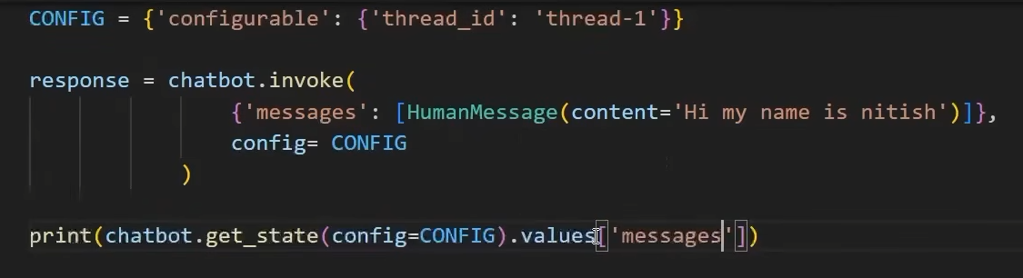
Result:- 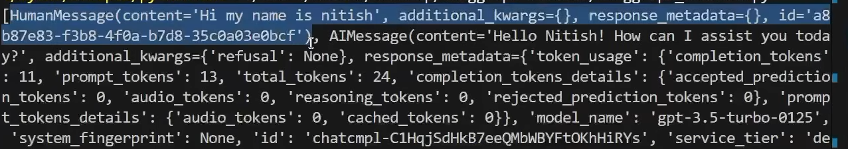

If message_history doesn't exist in st.session_state, we create it as an empty list to store the current chat messages.
If thread_id doesn't exist, we generate a new one using generate_thread_id() and store it in st.session_state. When New Chat is clicked, reset_chat() generates another new thread_id.
If chat_threads doesn't exist in st.session_state, we create it as an empty list to store the thread_id of all the previous chats.
Finally, we use the add_thread() function to add the newly created thread_id to st.session_state['chat_threads']. 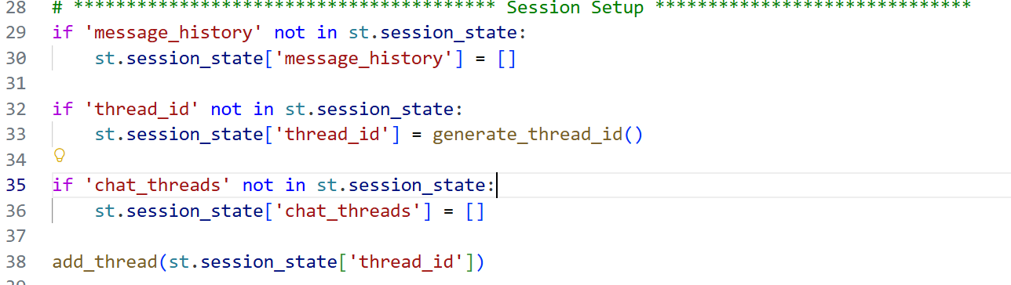
This is basically the side bar section.
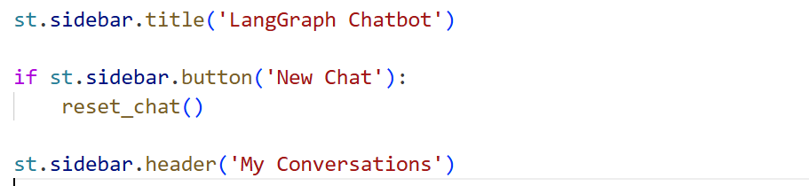
This code displays all the thread_ids in the sidebar so we can see and access our previous chats.
The [::-1] part reverses the chat_threads list, so the newest chats appear at the top and the older chats appear below them.
When we click a thread_id in the sidebar, we first store that ID in st.session_state['thread_id']. Then we use load_conversation() with that ID to retrieve the complete message history of that conversation.
We create a temporary list to convert the retrieved messages into the dictionary format used by message_history. After displaying the messages, we store this converted list in st.session_state['message_history'].
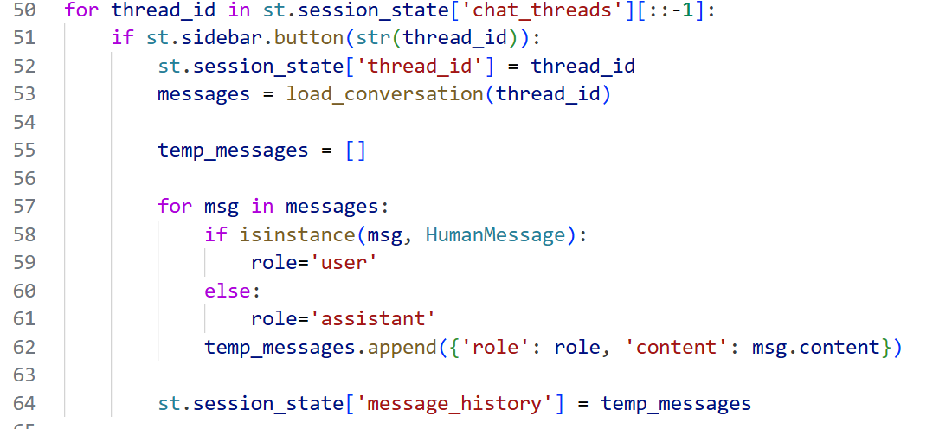

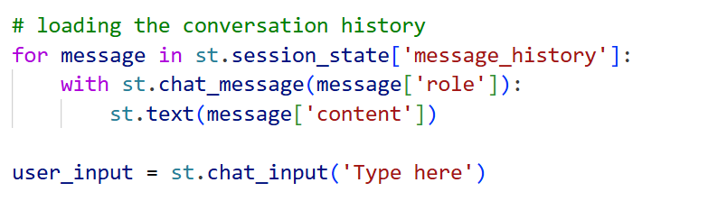

This code displays previous messages, takes a new user message, sends it to the LangGraph chatbot using the current thread_id, and streams only the AI response back to the UI.
- Loads and displays message_history.
- Gets new input using st.chat_input().
- Saves and displays the user's message.
- Uses the current thread_id to maintain the correct conversation.
- Streams the chatbot response using chatbot.stream().
- Filters out non-AI messages and displays only AIMessage content.
- Saves the complete AI response back into message_history.
